Slider Component

Items Tab

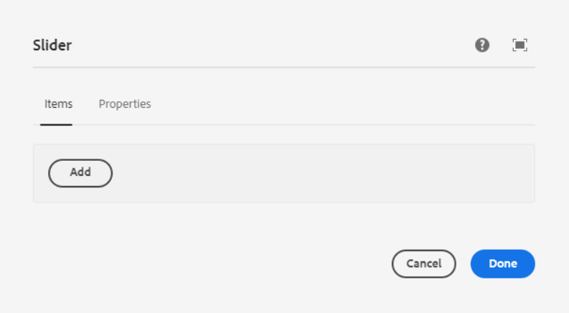

Inside Items Tab, we can add any component as per our requirement

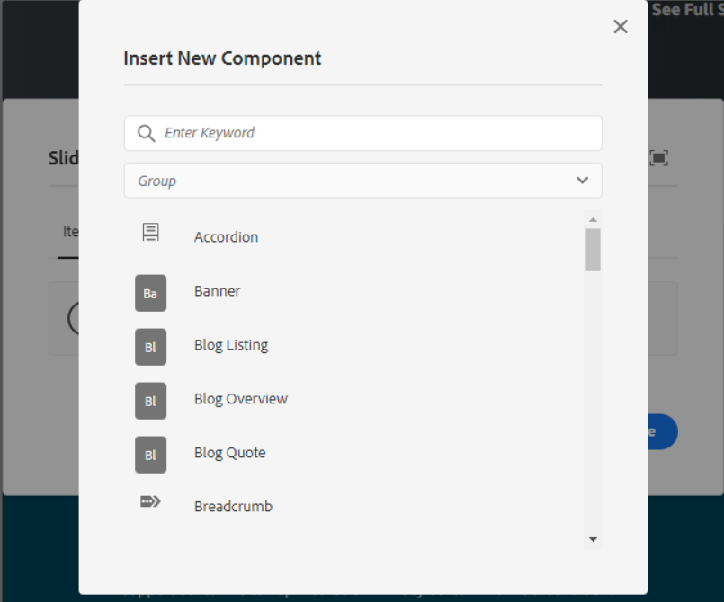

For E.g. If we add a slider Item component, then it will show as per the below screenshot.

We can add or delete items as pe the requirement.

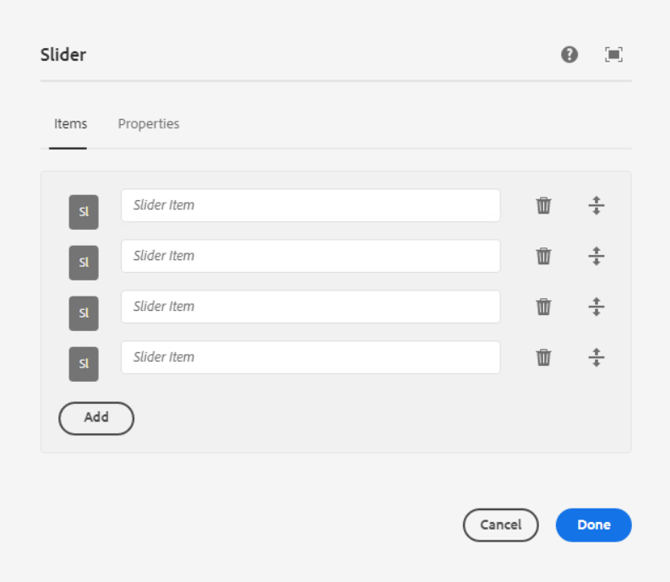

In Editor mode, we can able to see slider item inside the slider Component.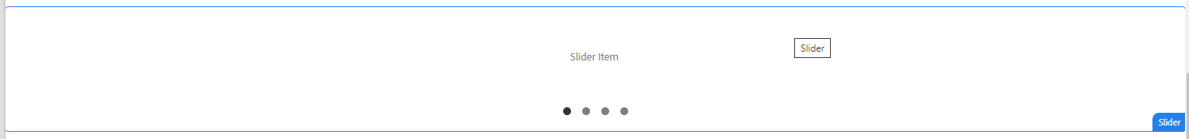

___________________________________________________________________

Properties Tab

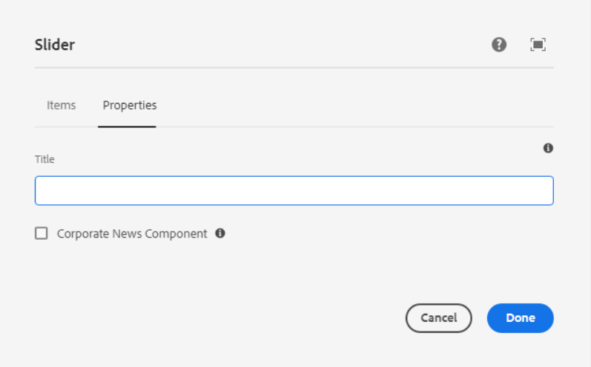

Title - Here we can add the Title of the component.

**Checkbox for corporate News component** - Check this to populate the component with corporate news blog page content then no need to author any other properties.

Page Reference - <https://www.ancestry.com/corporate/corporate-responsibility>

AEM URL - [https://author-ancestry-dev2.adobecqms.net/content/ancestry-corp/us/en](https://author-ancestry-dev2.adobecqms.net/content/ancestry-corp/us/en/about-ancestry/our-team.html?wcmmode=disabled)[/corporate-responsibility.html?wcmmode=disabled](http://localhost:4502/content/ancestry-corp/us/en/corporate-responsibility.html?wcmmode=disabled)

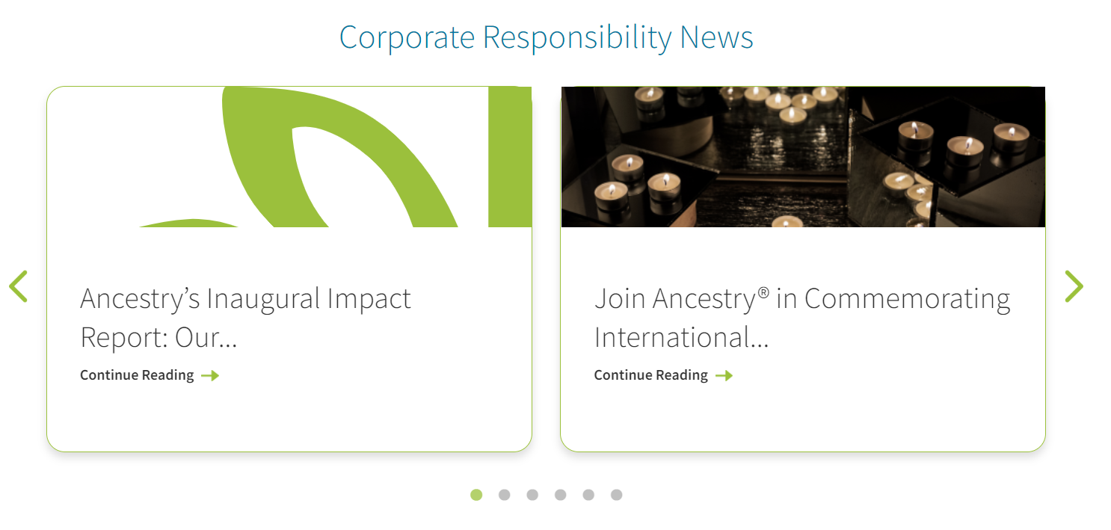

In this slider, if we want to see any blogs, then we have selected the blog category as Corporate Responsibility News in the blog properties as per below screenshot.



